INTERNSHIP PROJECT REPORT
ON
Windows Registry Change Monitoring System
Submitted as part of the Cyber Security Internship Program

Internship Period
December 2025 – June 2026

Supervised By: Submitted By:
Mr. Harshit Ravi
Organization:
Unified Mentor

INDEX

Sr. No. | Title | Page No.
1. | Abstract | 4
2. | Introduction | 5-6
3. | Problem Statement | 7
4. | Project Objective | 8
5. | Scope of the Project  - 5.1 In Scope  - 5.2 Out of Scope | 9
6. | Tools & Technologies Used | 10
7. | Methodology / Workflow | 11-13
8. | Implementation Details | 14-17
9. | Results & Findings | 18
10. | Security Recommendations | 19
11. | Learning Outcomes | 20
12. | Conclusion | 21
13. | Future Enhancements | 22
14. | References | 23

List of Figures

Figure No. | Description | Page No.
Figure 7.1 | System Workflow Diagram | 13
Figure 8.1 | Selected Registry Path in Registry Editor | 14
Figure 8.2 | Baseline Creation Output | 15
Figure 8.3 | Monitoring Process Started | 15
Figure 8.4 | New Entry Detection | 16
Figure 8.5 | Deleted Entry Detection | 16
Figure 8.6 | Malware Detection Alert | 16
Figure 8.7 | Continuous Monitoring Process | 17

1. ABSTRACT
The Windows Registry Change Monitoring System is a cybersecurity-focused project designed to monitor and detect unauthorized changes in the Windows Registry in real time. The Windows Registry is a centralized hierarchical database that stores configuration settings, system preferences, and application-related information required for the proper functioning of the operating system. Since almost every system process depends on the registry, any unauthorized modification can significantly affect system behavior and security.
Due to its critical importance, the Windows Registry is a common target for attackers and malicious software. Malware often modifies registry keys to establish persistence, allowing it to execute automatically whenever the system starts. Attackers may also use the registry to disable security mechanisms, alter configurations, or hide malicious activities within the system. These changes are usually performed silently, making them difficult to detect without proper monitoring tools.
This project addresses these challenges by implementing a monitoring system that continuously observes selected registry paths. The system begins by creating a baseline snapshot that represents the normal state of the registry and uses it as a reference for comparison. The monitoring module scans the registry at regular intervals and compares the current state with the baseline to identify any deviations.
If any change is detected, such as the addition of a new entry or deletion of an existing one, the system generates alerts to notify the user. Additionally, the system includes a basic malware detection mechanism based on keyword analysis. Entries containing suspicious keywords are flagged as potential threats, helping in early identification of malicious activity.
The results are displayed in real time through a command-line interface, making the system simple and effective for demonstration purposes. The alerts generated by the system provide clear information about the type of change and help users quickly understand system activity. It also assists in improving system awareness and strengthens basic defensive capabilities against registry-based threats. Overall, this project provides a practical understanding of registry-based attacks and demonstrates how real-time monitoring can be used as a defensive cybersecurity mechanism.

2. INTRODUCTION
The Windows Registry is one of the most important components of the Microsoft Windows operating system. It is a centralized and hierarchical database that stores configuration settings, system preferences, hardware details, and application-specific information. Every time the system starts or an application is executed, the registry is accessed to retrieve essential data required for proper functioning. Because of this, the registry plays a critical role in maintaining system stability, performance, and overall functionality.
The registry is divided into multiple keys and subkeys, which store values related to system configuration and user settings. These keys include important sections such as system startup programs, installed software, device drivers, and security configurations. Any modification in these keys directly impacts the behavior of the operating system. While the registry is designed to support smooth operation, it also becomes a sensitive and high-value target for attackers.
In the field of cybersecurity, the Windows Registry is often exploited by attackers to perform malicious activities. One of the most common techniques used by malware is to modify registry keys to establish persistence. Persistence allows malicious programs to remain active on the system even after a reboot, making them difficult to remove. By adding entries to autorun keys, attackers ensure that their malicious code executes automatically whenever the system starts.
Apart from persistence, attackers may also manipulate the registry to disable security mechanisms such as antivirus programs, firewall settings, or system updates. This enables them to operate undetected and maintain control over the system. Additionally, registry modifications can be used to alter system configurations, redirect processes, or hide malicious activities within legitimate system operations. These actions are usually performed silently in the background, making manual detection extremely difficult.
Due to these reasons, monitoring changes in the Windows Registry becomes an essential task in cybersecurity. Detecting unauthorized or suspicious modifications at an early stage can help prevent serious security breaches. Security professionals often use monitoring tools to track system-level changes and identify unusual behavior. However, many advanced tools are complex and not easily accessible for beginners or students.
This project focuses on developing a simple yet effective Windows Registry Change Monitoring System using Python. The main objective of this system is to monitor specific registry paths, detect any changes, and alert the user in real time.
The approach used in this project is based on baseline comparison. In this method, an initial snapshot of selected registry keys is created and stored as a reference. This snapshot represents the normal state of the system. Once the baseline is established, the system continuously monitors the registry and compares the current state with the baseline. Any deviation from the baseline is treated as a potential security event.
The monitoring system is capable of detecting different types of changes, including the addition of new entries and deletion of existing entries. These changes are immediately reported to the user through alerts. In addition, the system includes a basic mechanism to identify suspicious entries based on keyword analysis. For example, entries containing terms related to malware or disabling security features are flagged as potential threats.
The implementation of the system is done using Python programming language, which provides simplicity and flexibility. The built-in winreg module is used to interact with the Windows Registry and retrieve data from specified paths. The use of JSON format for storing the baseline ensures easy comparison and data handling. The system runs in a command-line environment, making it lightweight and efficient.
Another important aspect of this project is its educational value. It helps in understanding how the Windows Registry works and how attackers exploit it for malicious purposes. By implementing a monitoring system from scratch, users gain practical knowledge of system-level security mechanisms and detection techniques. This knowledge is highly valuable for students and professionals interested in cybersecurity.
Furthermore, this project demonstrates the importance of real-time monitoring in modern security systems. As cyber threats continue to evolve, proactive detection mechanisms become essential for protecting systems. Even a simple monitoring system like this can provide valuable insights into system activity and help in identifying potential threats before they cause significant damage.
In conclusion, the Windows Registry Change Monitoring System serves as a foundational cybersecurity project that highlights the significance of registry monitoring. It provides a practical solution for detecting unauthorized changes and understanding registry-based attack techniques. The concepts implemented in this project can be further extended to build more advanced and robust security solutions in the future.

3. PROBLEM STATEMENT
The Windows Registry plays a crucial role in the functioning of the Microsoft Windows operating system, as it stores essential configuration settings, system preferences, and application-related data. Due to its importance, any unauthorized or malicious modification in the registry can significantly impact system performance, stability, and security. However, one of the major challenges is that such changes often occur silently in the background and are not easily visible to the user.
In modern computing environments, cyber threats have become increasingly sophisticated, and attackers frequently target the Windows Registry to perform malicious activities. One of the most common issues is the use of registry keys for persistence, where malware creates or modifies entries to ensure that it runs automatically every time the system starts. This makes it difficult for users to detect and remove such threats, as they reappear even after system restarts.
Another significant problem is the lack of real-time monitoring of registry changes in most systems. While advanced security tools exist, they are often complex, resource-intensive, and not easily accessible for beginners or small-scale use. As a result, many systems remain vulnerable to unnoticed registry modifications, which can lead to serious security risks such as unauthorized access, data manipulation, or system compromise.
Additionally, manual monitoring of the registry is not practical due to its large size and complex hierarchical structure. It is nearly impossible for users to track every change occurring in the registry without automated tools. This creates a gap in system security, where malicious changes can go undetected for long periods of time.
Therefore, there is a need for a simple, efficient, and lightweight solution that can continuously monitor the Windows Registry and detect any unauthorized or suspicious changes in real time. Such a system should be capable of identifying additions, deletions, and potentially harmful entries while providing immediate alerts to the user.
The problem addressed in this project is to design and implement a registry monitoring system that overcomes these challenges by providing real-time detection, baseline comparison, and basic malware identification. This solution aims to enhance system security by enabling early detection of suspicious activities and improving overall awareness of registry-based threats.

4. PROJECT OBJECTIVES
The primary objective of the Windows Registry Change Monitoring System is to design and develop an efficient mechanism for monitoring and detecting unauthorized changes in the Windows Registry. Since the registry is a critical component of the operating system, ensuring its integrity is essential for maintaining system security and stability. This project aims to provide a practical solution that can identify suspicious activities in real time and alert the user accordingly.
One of the key objectives of this project is to monitor important registry paths, particularly those associated with system startup and application execution. These areas are often targeted by malware to establish persistence within the system. By continuously observing these registry keys, the system aims to detect any new entries or modifications that may indicate unauthorized activity.
Another important objective is to implement a baseline-based comparison technique. In this approach, an initial snapshot of the registry is created and stored as a reference point. This baseline represents the normal and trusted state of the system. The monitoring system then compares the current registry state with this baseline to identify any deviations. This method ensures accurate detection of changes, including additions and deletions of registry entries.
The project also aims to incorporate a basic malware detection mechanism. This is achieved by analyzing registry entries for suspicious keywords that are commonly associated with malicious behavior. By identifying such patterns, the system can flag potentially harmful entries and provide early warnings to the user. This enhances the overall effectiveness of the monitoring system in detecting threats.
Furthermore, the project aims to provide a simple and lightweight implementation that can be easily understood and used by students and beginners in cybersecurity. Unlike complex enterprise-level tools, this system focuses on clarity and practicality, making it suitable for learning purposes as well as basic monitoring tasks.
Overall, the objective of this project is not only to develop a functional registry monitoring system but also to enhance understanding of registry-based attacks and defensive techniques. It serves as a foundational step toward building more advanced cybersecurity solutions and promotes awareness of system-level security practices.

5. SCOPE OF THE PROJECT
The scope of the Windows Registry Change Monitoring System defines the boundaries and functionalities that the project covers. This system is primarily focused on monitoring specific areas of the Windows Registry to detect unauthorized or suspicious changes. It is designed as a lightweight and practical solution for understanding registry-based monitoring techniques and basic cybersecurity practices.
5.1 In Scope
The system monitors selected registry paths that are commonly targeted by malware, especially startup-related keys such as those responsible for auto-execution of programs during system boot. These areas are critical as attackers often use them to maintain persistence within the system. The project includes real-time monitoring of registry changes by periodically scanning the registry and comparing it with a predefined baseline. The baseline represents the normal state of the system and is used to identify deviations such as new entries or deleted values.
The system also implements a basic malware detection mechanism by checking registry entries against predefined suspicious keywords. If a match is found, the system flags it as a potential threat and generates a warning.
Additionally, the project provides real-time alerts through a command-line interface, informing the user about detected changes along with relevant details. Logging functionality is also included to keep a record of detected activities for analysis purposes.
5.2 Out of Scope
The project does not cover monitoring of the entire Windows Registry due to its complexity and size. It is limited to specific registry paths relevant to security. Advanced monitoring features such as complete registry auditing and deep analysis are not included.
The system does not provide a graphical user interface and operates entirely through a command-line interface. It also does not implement advanced malware detection techniques such as signature-based or behavior-based analysis, relying only on simple keyword matching.
Furthermore, the project does not take automated corrective actions such as removing or restoring registry entries. It only detects and reports changes. The system is also limited to a local environment and does not support remote monitoring or network-based analysis.
6. Tools & Technologies Used
The development of the Windows Registry Change Monitoring System involves the use of several tools and technologies that support efficient implementation and monitoring of registry changes. These technologies are selected based on their simplicity, effectiveness, and relevance to cybersecurity applications.
The primary programming language used in this project is Python. Python is widely preferred in cybersecurity due to its simplicity, readability, and strong library support. It allows easy interaction with system-level components and enables rapid development of monitoring scripts.
The project uses the built-in “winreg” module of Python to access and interact with the Windows Registry. This module provides functions to open registry keys, read values, and retrieve required information from specific registry paths. It is essential for both baseline creation and real-time monitoring.
For storing the baseline data, JSON format is used. JSON is lightweight and easy to manage, making it suitable for storing structured registry data. The baseline snapshot is saved in a JSON file, which is later used for comparison to detect any changes in the registry.
Visual Studio Code (VS Code) is used as the development environment. It is a lightweight and efficient code editor that provides features such as syntax highlighting and easy file management, which help in writing and testing the code effectively.
The project is implemented on the Microsoft Windows operating system, as the Windows Registry is a platform-specific feature. The scripts are executed using Command Prompt or PowerShell, where real-time alerts are displayed to the user.
Basic cybersecurity concepts such as real-time monitoring, baseline comparison, and keyword-based detection are also applied in this project. These techniques help in identifying unauthorized or suspicious changes in the registry.
Overall, the selected tools and technologies ensure that the system remains simple, efficient, and suitable for both learning and demonstration purposes.

7. Workflow / Architecture
The workflow and architecture of the Windows Registry Change Monitoring System define the complete operational process of how the system detects unauthorized changes in the Windows Registry. The system is designed in a structured and modular manner, allowing it to perform continuous monitoring, comparison, and alert generation efficiently. The architecture ensures that each component performs a specific function while contributing to the overall goal of detecting suspicious registry activities in real time.
The workflow begins with the selection of specific registry paths that need to be monitored. These paths are chosen based on their importance in system operations, particularly those related to startup programs and system configuration. Since attackers often target these locations to establish persistence, monitoring them is essential for maintaining system security.
The first major step in the workflow is baseline creation. In this phase, the system scans the selected registry paths and captures their current state. This data includes registry key names and associated values, which are then stored in a structured format such as a JSON file. The baseline acts as a reference point that represents the normal and trusted condition of the registry. It is an essential component, as all future comparisons depend on this initial snapshot.
After the baseline is created, the system enters the continuous monitoring phase. In this stage, the monitoring module repeatedly scans the same registry paths at fixed intervals. This ensures that any changes occurring in the registry are captured in near real time. The monitoring process runs in a loop, allowing the system to function continuously without requiring manual intervention.
The next stage is the comparison process, where the current registry data is compared with the stored baseline. This step is responsible for identifying differences between the two states. The system carefully analyzes the data to determine whether any new entries have been added, existing entries have been removed, or values have been modified. This comparison is a critical step in detecting unauthorized changes.
Once differences are identified, the system proceeds to the classification stage. In this phase, detected changes are categorized into different types such as additions, deletions, or modifications. This classification helps in understanding the nature of the change and provides clarity in alert messages. It also ensures that the system can respond appropriately based on the type of detected activity.
Following classification, the system performs analysis for potential threats. This is achieved using a keyword-based detection mechanism. The system checks the names of registry entries against a predefined list of suspicious keywords that are commonly associated with malware. If a match is found, the system flags the entry as a potential threat and generates a warning message. This step enhances the system’s ability to identify malicious activities at an early stage.
After analysis, the system generates alerts to inform the user about detected changes. These alerts are displayed in real time through a command-line interface. Each alert includes detailed information such as the type of change, the affected registry path, and the name of the entry. This allows the user to quickly understand what has occurred and take necessary actions.
In addition to alert generation, the system maintains logs of all detected changes. Logging is an important feature as it provides a history of system activity. These logs can be used for further analysis, troubleshooting, and understanding patterns of registry modifications over time. It also helps in improving the system by identifying frequent or repeated changes.
The architecture of the system is modular in nature, consisting of multiple components such as the baseline module, monitoring module, comparison module, detection module, and alert module. Each module operates independently but is connected through a well-defined workflow. This modular design improves the scalability and maintainability of the system, allowing future enhancements to be easily implemented.
Another important aspect of the architecture is its simplicity and efficiency. The system is designed to be lightweight, ensuring that it does not consume excessive system resources while performing continuous monitoring. This makes it suitable for practical use as well as for educational purposes.
The workflow operates in a continuous loop, where the system repeatedly monitors, compares, detects, and alerts. This cyclic process ensures that the system remains active at all times and can detect changes as soon as they occur. The efficiency of this workflow makes it effective in identifying both normal and suspicious registry activities.
Overall, the workflow and architecture of the system provide a clear and structured approach to registry monitoring. By combining baseline comparison, real-time detection, and alert generation, the system successfully demonstrates how cybersecurity techniques can be applied to protect critical system components such as the Windows Registry.
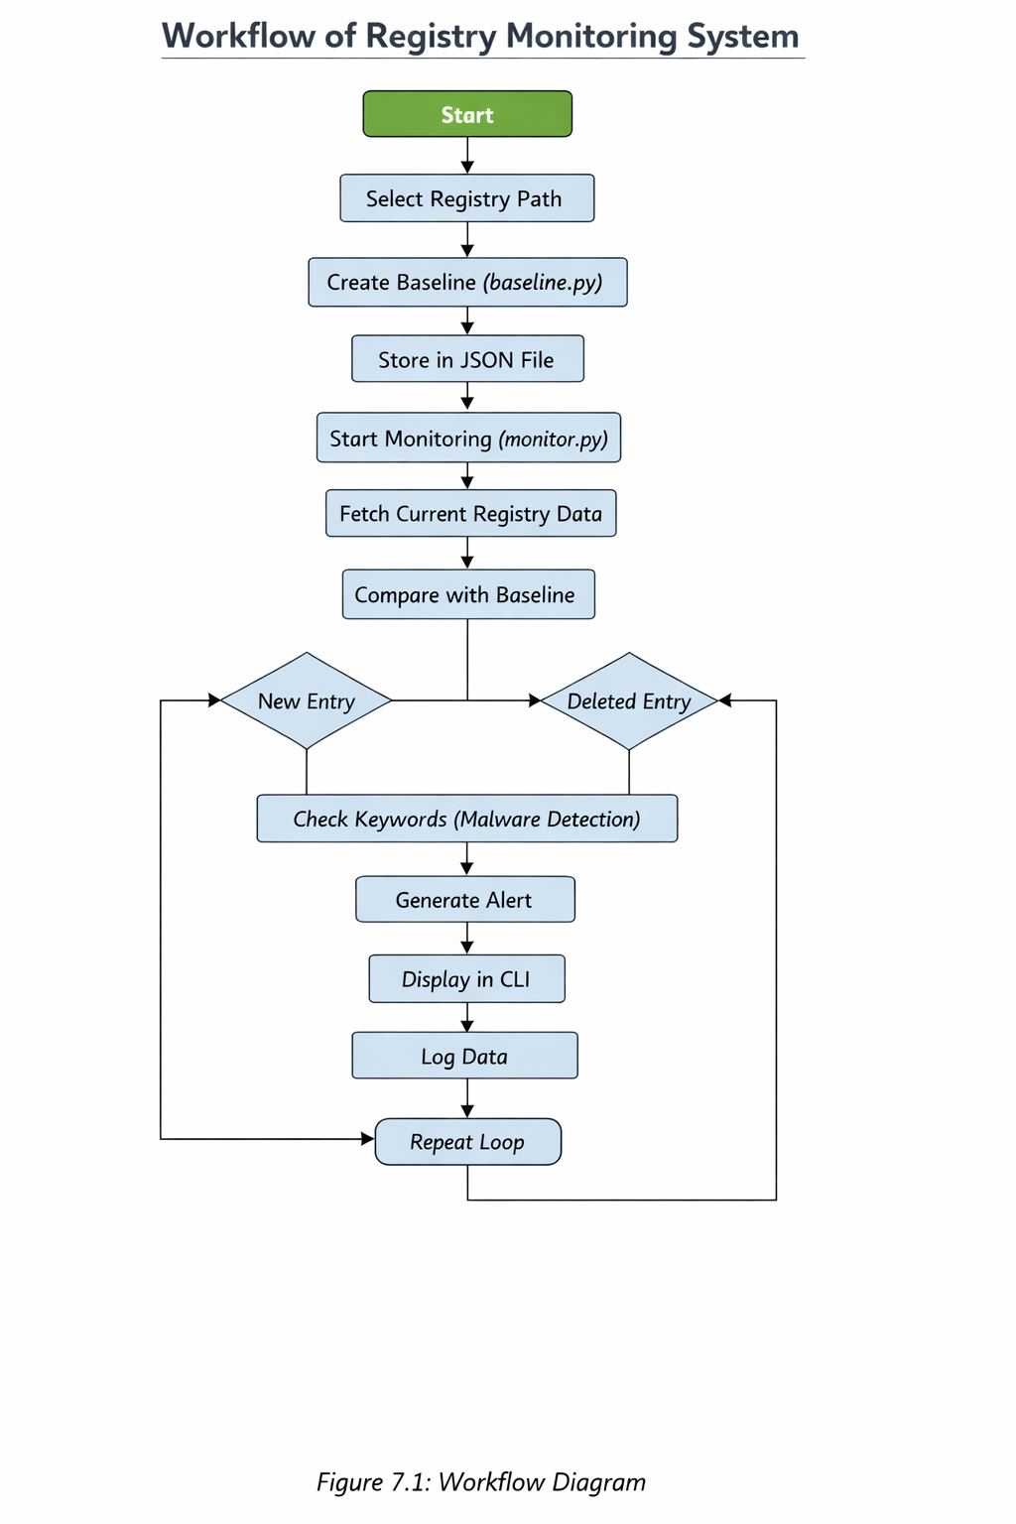
- Implementation Details
The implementation of the Windows Registry Change Monitoring System is carried out in a step-by-step manner. Each step represents a specific function of the system and helps in understanding the working process clearly.

Step 1: Selection of Registry Path
In the first step, the registry path to be monitored is selected. In this project, startup-related registry paths are chosen because they are commonly used by malware to execute automatically when the system starts.
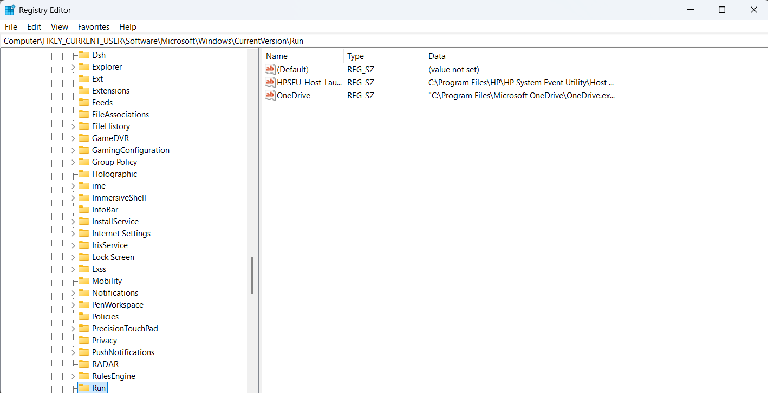
Figure 8.1: Selected Registry Path in Registry Editor

Step 2: Baseline Creation
In this step, the baseline of the registry is created using the baseline.py script. This script scans the selected registry path and stores all entries in a JSON file. This baseline acts as a reference for future comparisons.
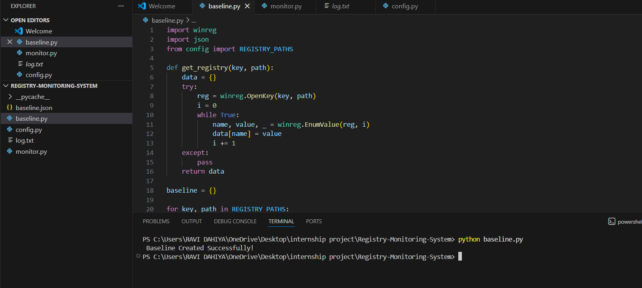
Figure 8.2: Baseline Creation Output

Step 3: Start Monitoring Process
The monitoring process is started using the monitor.py script. This script continuously scans the registry and compares it with the baseline.
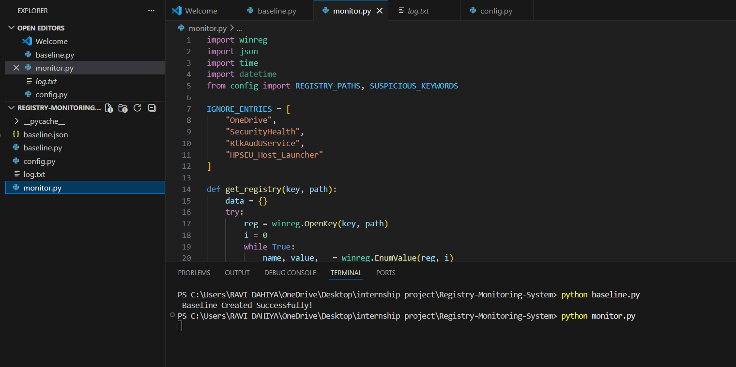
Figure 8.3: Monitoring Process Started

Step 4: Detection of New Entry
When a new registry entry is added, the system detects it and generates an alert.
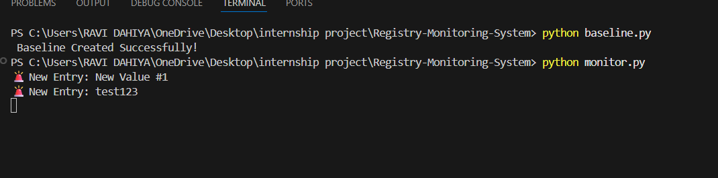
Figure 8.4: New Entry Detection

Step 5: Detection of Deleted Entry
If an existing registry entry is removed, the system detects it as a deletion.
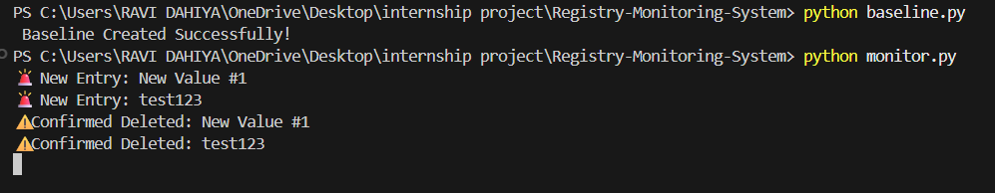
Figure 8.5: Deleted Entry Detection

Step 6: Malware Detection
The system checks for suspicious keywords such as "malware". If detected, it generates a warning.
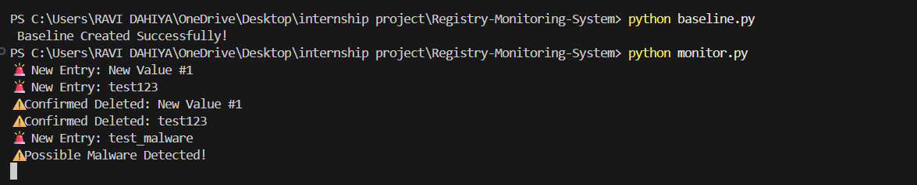Figure 8.6: Malware Detection Alert
Step 7: Continuous Monitoring Loop
The system continuously runs in a loop and keeps monitoring registry changes in real time.
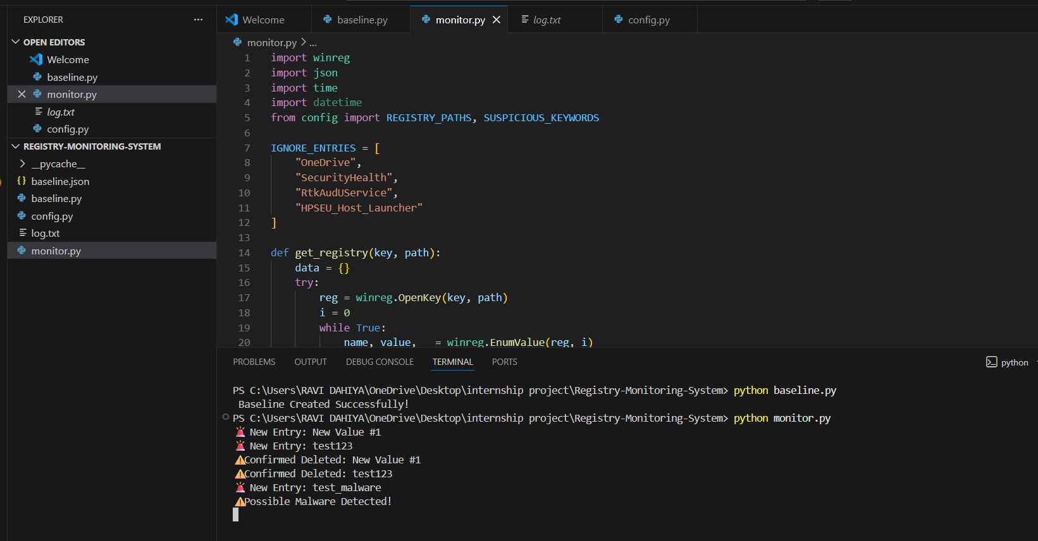
Figure 8.7: Continuous Monitoring Process

9. Results and Findings
The results of the Windows Registry Change Monitoring System demonstrate that the implemented solution is effective in detecting and analyzing registry changes in real time. The system was tested under different conditions to evaluate its performance, accuracy, and reliability.
The initial step of selecting the registry path was successfully completed, as shown in Figure 8.1. The selected path includes startup-related entries, which are critical from a security perspective. This confirms that the system focuses on relevant areas that are commonly targeted by malicious activities.
The baseline creation process was executed successfully using the baseline script. As illustrated in Figure 8.2, the system was able to scan the registry and store its state without any errors. This baseline serves as a reliable reference point for detecting future changes.
The monitoring process was initiated using the monitoring script, and it functioned continuously as expected. Figure 8.3 shows that the system was able to run in real time and actively monitor registry changes without interruption. This confirms the stability of the monitoring mechanism.
During testing, when new registry entries were added, the system successfully detected them and generated alerts. As shown in Figure 8.4, the system accurately identified newly added entries, demonstrating the effectiveness of the comparison process.
Similarly, when registry entries were deleted, the system correctly identified the changes and generated appropriate alerts. Figure 8.5 illustrates that the system is capable of detecting deletions accurately, which is essential for tracking unauthorized modifications.
The malware detection feature was also tested by introducing entries with suspicious keywords. As shown in Figure 8.6, the system successfully flagged such entries as potential threats and generated warning messages. This confirms that the keyword-based detection mechanism is working as intended.
Furthermore, the system demonstrated continuous monitoring capability by running in a loop and detecting multiple changes over time. Figure 8.7 shows that the system consistently generated alerts for different types of activities, indicating its reliability and efficiency.

10. Security Recommendations
The Windows Registry is a critical component of the operating system, and protecting it from unauthorized access and malicious modifications is essential for maintaining system security. Based on the implementation and results of the Windows Registry Change Monitoring System, several security recommendations can be proposed to enhance system protection.
One of the primary recommendations is to restrict unauthorized access to the registry. Users should avoid granting administrative privileges to unknown applications or untrusted users, as elevated permissions allow direct modification of registry keys. Proper access control should be maintained to ensure that only authorized users can make changes.
It is also recommended to continuously monitor registry changes using automated tools such as the developed monitoring system. Real-time monitoring helps in early detection of suspicious activities and reduces the risk of security breaches, especially in critical registry paths.
Maintaining regular backups of the registry is another important practice. In case of accidental or malicious changes, backups can be used to restore the system to a safe state, preventing system instability and data loss.
Users should be cautious while installing new software, as malicious programs often attempt to modify the registry during installation. Only trusted applications should be installed, and unnecessary or unknown programs should be avoided.
The use of updated antivirus and security tools is also essential. These tools help in detecting and preventing threats that target the registry. Keeping them updated ensures protection against new and evolving cyber threats.
Additionally, enabling system security features such as User Account Control (UAC) adds an extra layer of protection by preventing unauthorized system-level changes. Users should also periodically review important registry entries to identify any suspicious activity.
Overall, applying these recommendations can significantly reduce the risk of registry-based attacks and improve the overall security of the system.

11. Learning Outcomes
The development of the Windows Registry Change Monitoring System provided valuable learning experiences in the field of cybersecurity and system-level programming. This project helped in understanding how critical components of an operating system, such as the Windows Registry, function and how they can be targeted by malicious activities.
One of the key learning outcomes of this project is the understanding of the structure and importance of the Windows Registry. The project provided practical exposure to registry paths, keys, and values, and demonstrated how system and application configurations are stored and managed. This knowledge is essential for identifying potential security vulnerabilities within the system.
The project also enhanced programming skills, particularly in Python. The use of Python for interacting with the Windows Registry helped in understanding how system-level operations can be performed using a high-level programming language. Concepts such as file handling, data storage using JSON, and script-based automation were also learned during the implementation.
The implementation of baseline comparison introduced the concept of maintaining a reference state and detecting deviations from it. This technique is widely used in cybersecurity for identifying unauthorized changes and ensuring system integrity. Learning this approach helped in understanding how security tools track system modifications.
The project also provided knowledge about basic malware detection techniques. By implementing keyword-based detection, the project demonstrated how suspicious patterns can be identified within system data. Although simple, this approach helped in understanding the foundation of threat detection mechanisms.
Additionally, the project improved problem-solving and debugging skills. During development, various challenges such as handling errors, managing continuous loops, and ensuring accurate detection were encountered and resolved. This strengthened the ability to analyze issues and develop effective solutions.
Overall, this project served as a practical learning experience that combined theoretical knowledge with hands-on implementation, thereby improving both technical skills and cybersecurity awareness.
12. Conclusion
The Windows Registry Change Monitoring System is a practical cybersecurity project that demonstrates how critical system components can be monitored to detect unauthorized changes. The Windows Registry plays a vital role in the functioning of the operating system, and any modification to it can directly impact system behavior, performance, and security. Therefore, monitoring the registry is an important step toward maintaining system integrity.
This project successfully implemented a system that continuously monitors selected registry paths and detects changes in real time. By creating a baseline and comparing it with the current state of the registry, the system is able to identify new entries and deleted entries accurately. This approach ensures that any deviation from the normal state is detected efficiently.
The integration of a basic malware detection mechanism further enhances the functionality of the system. By analyzing registry entries for suspicious keywords, the system is able to flag potential threats and generate warning messages. Although simple, this technique provides an effective way to understand how malware detection works at a basic level.
The system also provides real-time alerts through a command-line interface, allowing users to quickly identify and respond to changes. The continuous monitoring capability ensures that the system remains active and responsive at all times, making it reliable for detecting ongoing activities within the registry.
Throughout the development of this project, various cybersecurity concepts such as real-time monitoring, baseline comparison, and threat detection were applied. The project not only demonstrates the technical implementation of these concepts but also highlights their importance in protecting system resources.
In addition, the project is designed to be simple and lightweight, making it suitable for educational purposes and beginner-level cybersecurity applications. It provides a clear understanding of how monitoring systems work and how they can be used to enhance system security.
Overall, the Windows Registry Change Monitoring System achieves its objective of detecting unauthorized registry changes and providing timely alerts. The project serves as a foundation for developing more advanced security solutions and contributes to a better understanding of system-level cybersecurity practices.
13. Future Enhancements
The Windows Registry Change Monitoring System developed in this project provides a basic yet effective approach for detecting registry changes. However, there are several areas where the system can be further improved to enhance its functionality, efficiency, and usability.
One of the major enhancements can be the implementation of a graphical user interface (GUI). Currently, the system operates through a command-line interface, which may not be user-friendly for non-technical users. A GUI-based system would make it easier to visualize alerts, logs, and registry changes in a more organized and interactive manner.
Another important improvement would be the integration of advanced malware detection techniques. The current system uses a simple keyword-based detection mechanism, which can be enhanced by implementing signature-based or behavior-based analysis. This would allow the system to detect more sophisticated threats with greater accuracy.
The system can also be extended to monitor a larger number of registry paths, including system-wide keys. Expanding the monitoring scope would improve the overall security coverage and help in detecting a wider range of malicious activities.
Another enhancement could be the addition of real-time notifications through email or desktop alerts. This would ensure that users are informed immediately, even when they are not actively monitoring the command-line interface.
The logging mechanism can also be improved by storing logs in a structured database rather than simple files. This would make it easier to analyze historical data, generate reports, and identify patterns of registry changes over time.
Furthermore, the system can be integrated with other security tools such as antivirus software or intrusion detection systems. This integration would create a more comprehensive security solution capable of handling multiple types of threats.
Finally, performance optimization can be considered to reduce system resource usage during continuous monitoring. Efficient scanning techniques and optimized code can improve the overall performance and scalability of the system.
Overall, these enhancements can transform the current project into a more advanced and robust security tool, capable of handling real-world cybersecurity challenges more effectively.
14. References
- Microsoft Documentation – Windows Registry
- Python Official Documentation
- Python "winreg" Module Documentation
- Cybersecurity Fundamentals – Online Study Material
- Tutorials on Registry Monitoring using Python
- Research articles on Malware Persistence Techniques
- Online resources and technical blogs related to Windows Security

